GDC Kishtwar celebrating Swachhta Hi Sewa Programme from 15th September to 2nd October 2017 under Swachh Bharat.

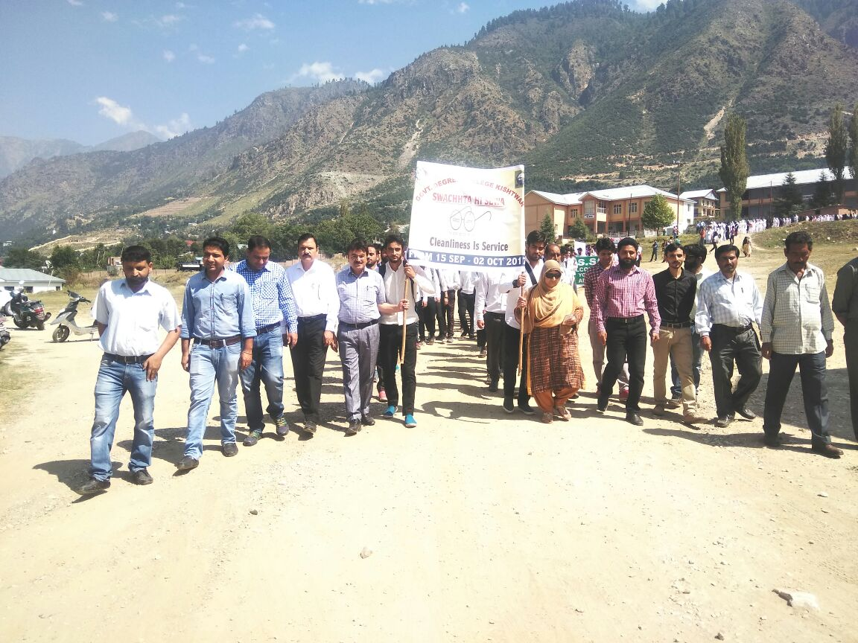
As a part of ongoing Nationwide Sanitation Campaign Swacchta Hi Sewa after a series of cleanliness drives in the college campus during previous days Government Degree College, Kishtwar on 21st September organized a Rally in the backdrop of Swacchta Hi Sewa program. Since 15th of September at the launch of the campaign all local fund and class 4th employees of the college along with sweepers were engaged in cleaning toilets and college campus under the close supervision of Prof. Shakila Begum, Principal of the college assisted by the faculty members, whereas on 19th of September a cleanliness drive was launched by the students in the campus where in different departments and laboratories were cleaned. Continuing with the same sprit the college arranged a rally today which was flagged of by Prof. Shakila Begum, Principal of the College with an aim to reinforce the concept of 'sanitation as everyone's business', re-energize Swachh Bharat Abhiyan and to intensify focus on cleanliness.
The rally started from the College campus, in which apart from the Faculty of the College, various Students, NSS Volunteers and NCC cadets with the help of banners and playcards took the message of cleanliness across the length and breadth of the city. Besides, recitation of slogans of cleanliness by the volunteers, there were also a few interactions with masses in the society. The rally after passing through the main market culminated back in the College campus, where the principal of the College Prof. Shakeela Begum while addressing the students informed about various activities to be taken by the College under Swacchh Bharat Mission in the coming days and thus stressed for active participation of all students, teaching and Non-teaching staff of the college in making campaign successful and to realize the dream of Clean India. She stressed the students and faculty members to actively participate in the campaign at individual levels starting from their own homes so as to make every nook and corner of the town neat and clean. She further added that this drive must not be taken only from 15th September to 2nd October 2017 but should be made as a routine part of their day today activities thereafter too. In her address principal appreciated the role of students, faculty, Convener Swachhta Hi Sewa Programme Dr. Barkat ALI, NCC Officer Prof. Satish Thakur, Program Officer NSS Prof. Faisal Mushtaq and Incharge Co-Curricular activities Dr. Ashaq Hussain for making the event a grand success.

